- Artifact Goal
Which option you chose
I selected Option #3: Creating an infographic.

What artifact you created
I designed a visual infographic that synthesizes a complex connection of how AI terms fit together into a streamlined, easily scannable narrative. Rather than relying on a traditional written format, this artifact maps out the core concepts, structural parameters, and key data points visually.

Why you chose this artifact
I chose this approach because it efficiently aligned with a current school assignment. Beyond efficiency, I prefer using infographics to communicate multifaceted information. They're effective at stripping away wordiness and I struggle with that, making it easier to convey critical points and logical flows that often become difficult to digest in long paragraphs or dense tables.

Who the intended audience is
The primary audience is my professor who need to quickly grasp if I understand the core concepts. It is designed for an audience that values a clear, high level overview but still requires an accurate, critical lens on the subject matter.

What a successful final version should accomplish
A successful final version should act as a standalone, pragmatic, quick reference guide. It must naturally guide the viewer's eye through the data, ensuring they immediately understand the key takeaways and actionable insights without needing supplementary text to decode the message.

- Tool Choice and Purpose
For this project, I utilized NotebookLM to assist with the content synthesis phase of my infographic. Because I had already developed detailed definitions and a connection flow paragraph, this tool was the logical choice. It uses source documents to infer and develop outputs, rather than pulling from external, generic, generalized, external training data. I expected the tool to help distill my dense text into the concise, scannable bullet points required for a visual medium while preserving my original structural logic. I planned to maintain strict editorial authority over the final product. I took responsibility for designing the actual visual layout, verifying that the AI's summarization did not dilute or misrepresent my definitions, and serving as the final human in command to ensure the artifact met rigorous standards for accuracy and clear communication. Through several iterations, I gave up on NotenookLM because it made horrible errors when adding in text to the visual and switched to ChatGPT as it seemed to create better visuals that fit the picture I was trying to create from my mind.

- Prompt or Instructions Used
Task: Design and layout a concept connection map that illustrates how the provided artificial intelligence ideas interconnect to build a cohesive, clear framework for understanding AI.
Context: This map is being developed as an academic and professional synthesis artifact, translating dense definitions and connection flows into a structured visual format.
Audience: Academic evaluators, peer practitioners, and technical stakeholders who value accuracy, logic, and clean organization.
Format: A structured concept map layout (or textual outline formatted for map generation) detailing nodes and directional relationships.
Tone & Style: Professional, objective, clear, and optimized for high scan ability and logical flow.
Constraints: Maintain absolute fidelity to the source definitions provided. Ensure zero spelling or typographical errors across all labels, titles, and descriptions. Double check spelling and words for accuracy.
What to Include: Core conceptual nodes, directional links or transition phrases explaining how ideas relate, and logical categorical groupings.
What to Avoid: Extraneous external filler, speculative claims not supported by the source text, and visual clutter or tangled cross-hatching.

- AI Output Summary
I couldn’t use the output there were too many errors and nonsense words.
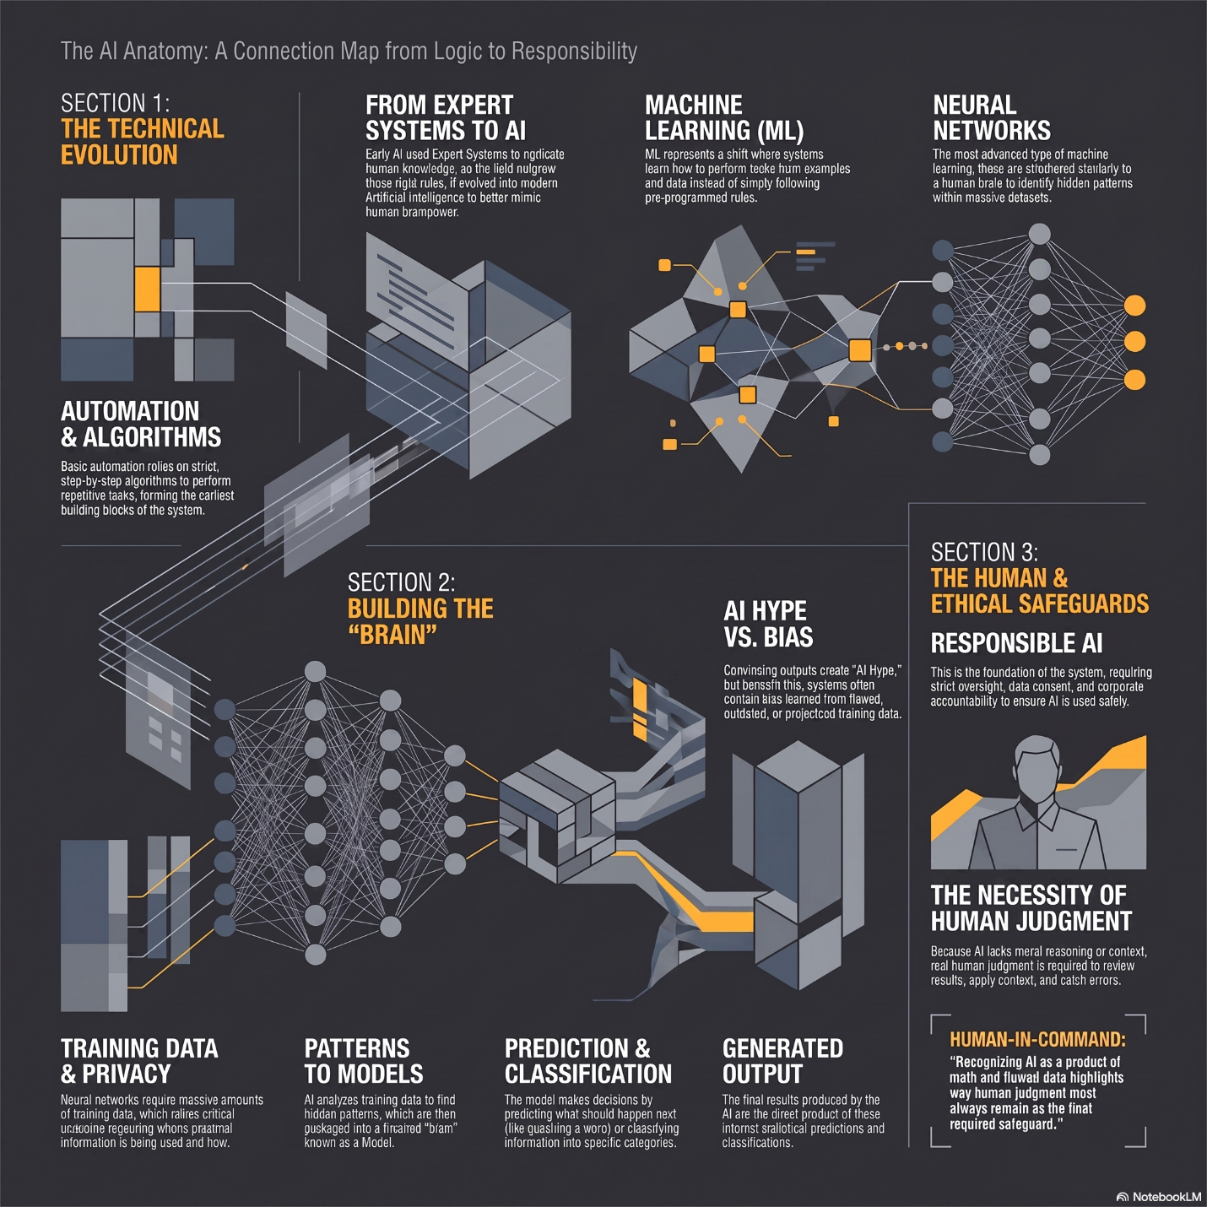
Attempt 1 Image

- Revision and Human Contribution
I revised the prompt and tried again.
Task: Design and layout a detailed concept connection map that illustrates how core artificial intelligence ideas interconnect, explaining precisely how these relationships build a clear, comprehensive understanding of AI.
Context: Developed as a rigorous academic and professional synthesis artifact, translating detailed technical definitions and connection flows into an optimized visual layout.
Audience: Academic evaluators, peer practitioners, and technical stakeholders who demand high structural fidelity, precision, and clarity.
Format: A clean, crisp hierarchical or network-based concept map structure utilizing distinct nodes and explicit directional linking phrases.
Tone & Style: Professional, objective, minimalist, and visually clean (easy on the eyes with balanced whitespace and zero clutter).
Constraints: Maintain absolute fidelity to the source document's language and definitions. Ensure every label uses correct, verified real words with zero spelling, typographical, or grammatical errors.
What to Include: Core conceptual nodes, include directional links with descriptive verbs (e.g., "enables," "requires," "structures"), and logical categorization tiers.
What to Avoid: Extraneous external filler, convoluted cross-hatching, ambiguous single-word links, and speculative concepts unsupported by the source text.
The output was better than before, but still contained errors and spelling mistakes.

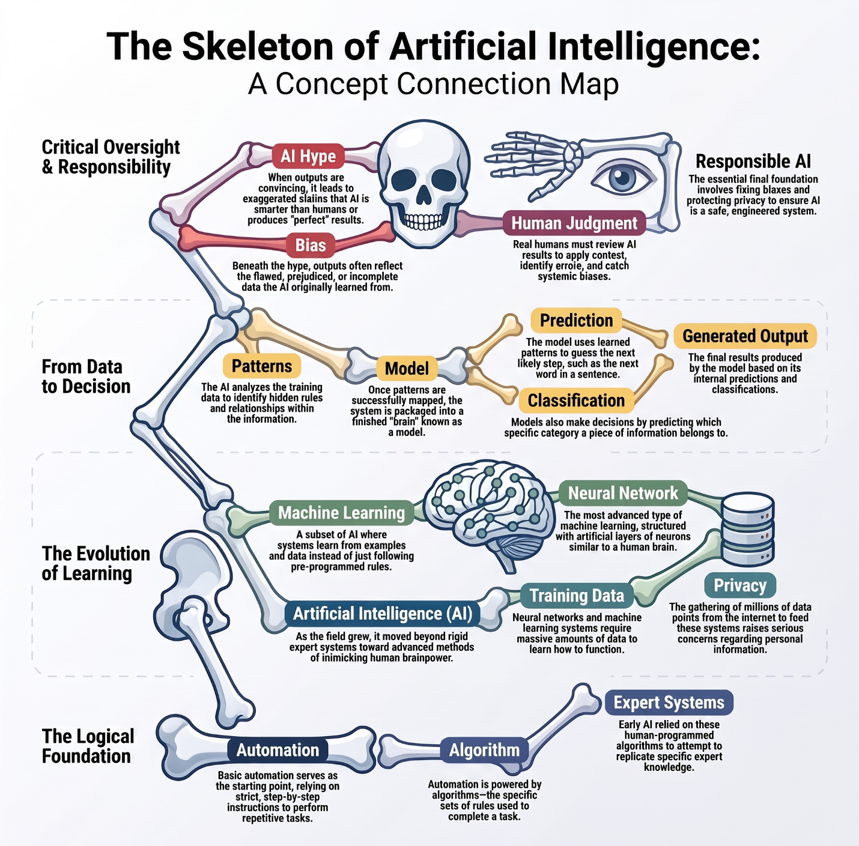
Attempt 2 image
I used the same prompt, but changed the NotebookLM setting from auto-select to professional
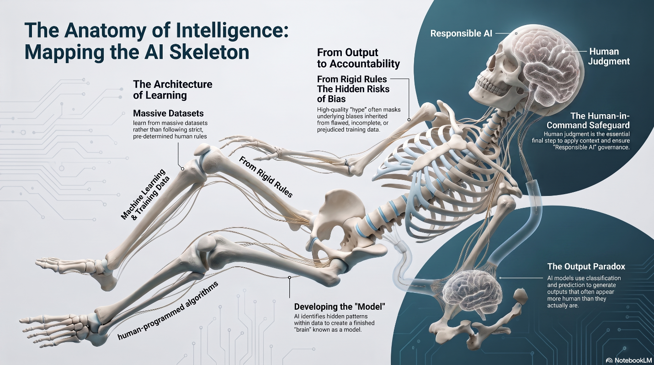
Attempt 3 image

Then I changed to Chat GPT and tried the prompt again
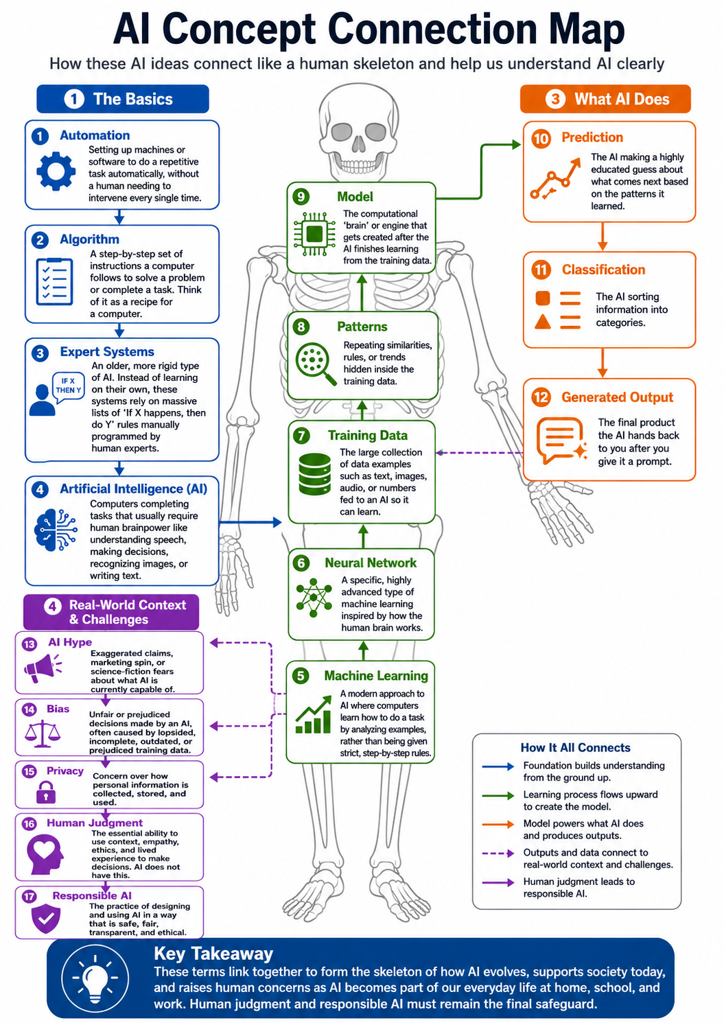
ChatGPT attempt 1
Revision Prompt: I liked this output much better, so I asked it to revise the image with this prompt:
I really like the generated image, but there are some issues, the color coding, numbering and connection legend don't quite make logical sense. Can you retry.
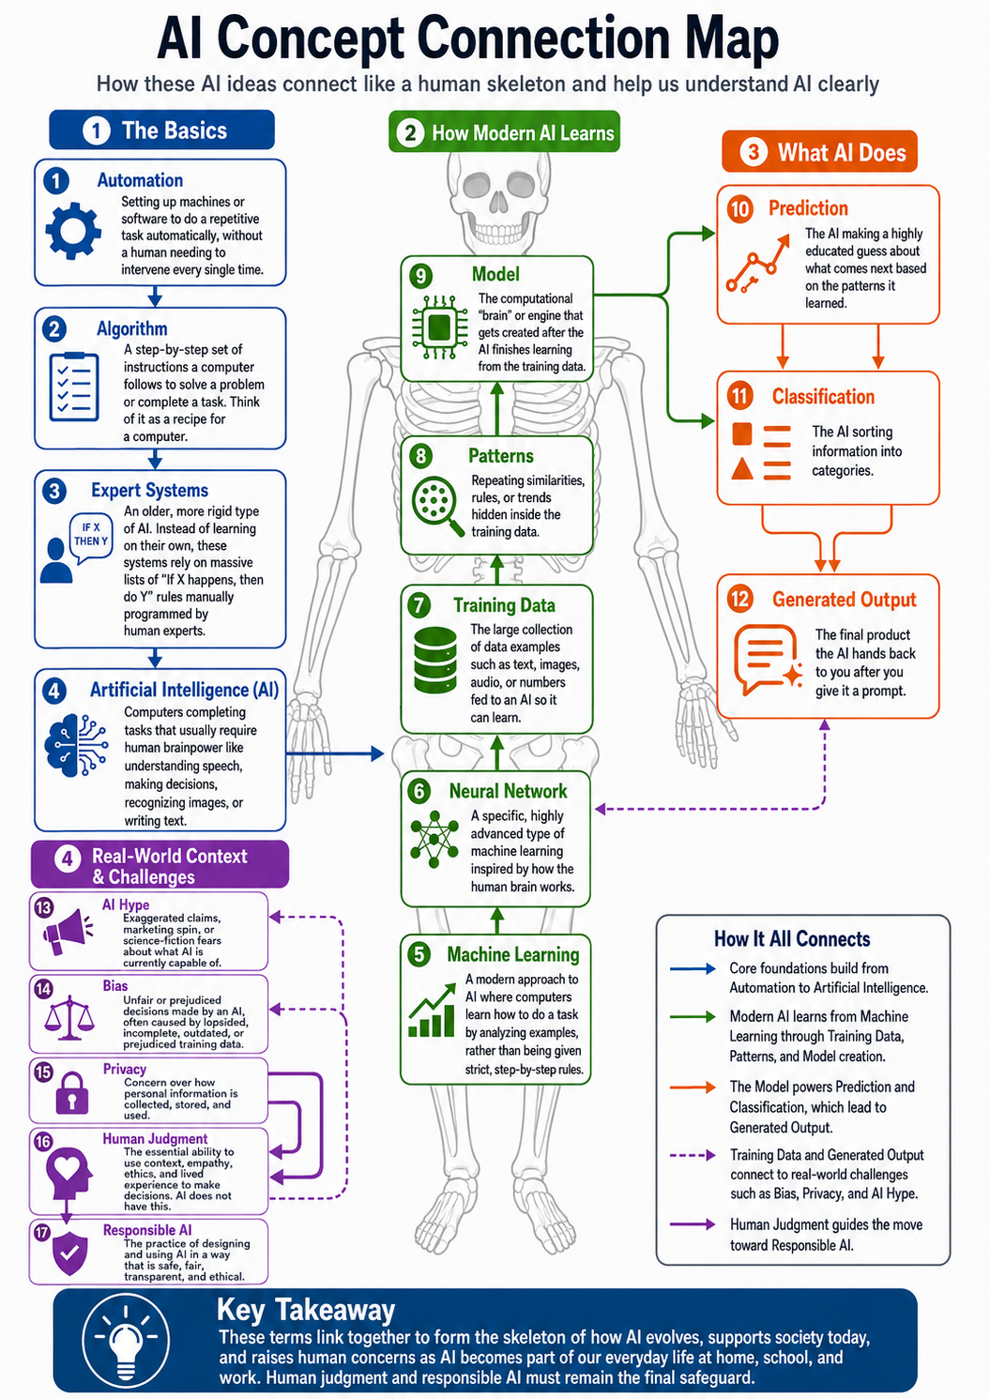
I liked this one much better and it was the one I ended up using. From a tools perspective ChatGPT had superior outputs for accuracy when using source documents to infographics compared with NotebookLM in this instance.

Reflecting on My Prompt Revision and Improvement Process
When refining my initial prompt into a structured, multi element instruction set, I enhanced how the AI tool interpreted and executed the task. Below is my evaluation of the revisions, edits, and strategic decisions I made throughout this process.

What I Kept
I kept the core objective entirely intact. The fundamental goal to design a concept connection map illustrating how AI ideas interconnect and clarify overall understanding. I also preserved my priority on spelling accuracy, source fidelity, and real word verification.

What I Changed
I transformed my structural approach to prompting. Instead of relying on a dense, conversational paragraph containing multiple instructions lumped together, I reorganized my instructions into distinct, categorical parameters (Task, Context, Audience, Format, Tone, Style, Constraints). This shifted my prompt from a vague request into a precise professional blueprint.

What I Removed
I removed redundant phrasing and subjective qualifiers and replaced them with objective, functional design constraints like minimalist layout, balanced whitespace, and zero visual clutter. This gave the AI tool concrete parameters to follow rather than abstract adjectives.

What I Added
I introduced several critical layers of control
Context & Audience: I explicitly defined the artifact as an academic and professional synthesis for evaluators and practitioners who demand rigor.
Explicit Boundaries: I added precise categories for What to Include (core nodes, explicit directional verbs) and What to Avoid (external filler, cross-hatching, unsupported concepts).

What I Verified
I checked the prompt against my original source documents and assignment requirements to ensure no critical constraints were lost. I applied special verification to the rules regarding source alignment, confirming that my prompt strictly prohibited external hallucinations or unverified terminology.

My Decisions as the Human Creator
As the human-in-command, I exercised editorial authority by moving away from passive prompt generation and adopting an active architectural role. I determined that achieving a professional standard requires moving beyond simple conversational requests to enforce strict guardrails on tone, structure, and factual grounding. After several failed iterations, I decided to start again in ChatGPT.

How I Made the Artifact More Useful, Accurate, and Audience-Appropriate
Through this iterative redesign, I made the final artifact vastly more useful and accurate. By structuring my prompt with rigid constraints and clear categorical guidelines, I mitigated the risk of generic AI filler or formatting errors. The resulting prompt forced the AI to produce an output that is logically sound, visually disciplined, highly scannable, and completely faithful to my original source material.

- Quality and Responsibility Check
Is the information accurate?
Yes, absolutely. After running into repeated roadblocks with NotebookLM where multiple prompt adjustments still failed to yield a usable result—shifting to a tightly structured prompt in ChatGPT produced an output where the content, definitions, and conceptual connections were completely accurate and aligned precisely with my source document.

Did you verify important claims, facts, or sources?
Yes. As the human in command, I cross-referenced the final ChatGPT output line by line against my original source text to confirm there were no hallucinations, spelling errors, or distorted logic.

Does it match the intended audience?
Yes, it is tailored directly for academic evaluators and professional peers who demand high-level structural rigor, technical precision, and logical clarity.

Is the tone appropriate?
Yes, it maintains a strictly objective, professional, and academic tone that avoids casual filler and fits a formal conceptual framework.

Is the format useful?
Yes, the concept map format is practical, breaking down dense theoretical relationships into clear, digestible, and scannable visual nodes that make complex ideas easy to navigate.

Is the artifact clear and easy to understand?
Yes. By enforcing strict constraints on layout and eliminating visual clutter, the final graphic clearly illustrates how the concepts interconnect and build a cohesive understanding of AI.

Does it maintain your own voice, judgment, or creative direction?
Yes. Although ChatGPT generated the final layout, I dictated every operational constraint, established the organizational categories, and exercised strict editorial authority to ensure the artifact reflected my core conceptual framework.

Could anything be misleading?
No. Because I enforced strict source fidelity and eliminated speculative language or cross-hatching, the relationships presented are strictly bound to verified definitions, leaving no room for misinterpretation.

Does the artifact need alt text, captions, clearer layout, or accessibility improvements?
Yes. To ensure complete accessibility for all users, the final presentation requires descriptive alt text for screen readers and concise captions to explain the directional flow of the conceptual nodes.

Should AI use be disclosed in this context?
Yes. Transparency is essential in professional and academic work. Disclosing the use of AI highlights my active role as the human in command who guided, rigorously tested, verified, and finalized the product.

- Final Reflection
Creating this artifact taught me that while AI is helpful for rapidly synthesizing dense information into a structured visual layout, its utility depends entirely on human direction, as evidenced by my early trials with NotebookLM before achieving success with a refined, multi element prompt in ChatGPT. The biggest limitation of the AI output was its initial lack of structural discipline without strict guardrails, meaning I had to step in as the human in command to verify the output matched the source, check for spelling and real word accuracy, and enforce constraints that the tool could not establish on its own. Next time, I would bypass trial and error attempts on unsuited platforms and implement a highly structured, multi parameter prompting framework from the very beginning. This assignment changed my perspective on authorship by reinforcing that while AI can accelerate the mechanics of creation, true quality, critical judgment, and intellectual ownership remain exclusively human responsibilities.

